Paper Title

Author’s Name (1)
University/ Institute Name
Corresponding Author Email

Author’s Name (2)
University/ Institute Name
Corresponding Author Email

TITLE OF PAPER GETS REPEATED HERE EXACTLY AS IT APPEARS ON TITLE PAGE
Abstract: These guidelines provide instructions to format your full paper. Please write directly into the template or copy your finished text into it choosing ‘match destination formatting’. Please use the predefined formatting styles instead of applying your individual settings. The full paper shall be written in compliance with these instructions. Please review this document to learn about the formatting of text, table captions and references. The conference proceedings will be published in an electronic format. The Abstract should be no more than 200 words and one paragraph only. Avoid quotation and citing references in your abstract. [this paragraph is formatted as Abstract]
Keywords: maximum 5 keywords, paper format, instructions, use of template [the keywords are formatted as Keywords]

Introduction [this is formatted as Heading 1]

It is expected that authors will submit carefully written and proofread material. Careful checking for spelling and grammatical errors should be performed. Papers should clearly describe the background of the subject, the authors’ contribution, including the methods used, results and concluding discussion on the importance of the work from both scholarly and managerial perspectives. [Paragraph]
The Full Paper must be written in English within 10 pt Arial. The text should be justified. The Full Paper including figures, tables and references must have a minimum length of 6 pages and cannot exceed 15 pages.
All accepted papers will be published in the online proceedings which will have an ISSN number and be made accessible from the conference website after the conference. Following the conference papers will be given a DOI reference to ensure they are picked up in scholarly web-searches. We aim to produce conference proceedings of a professional and consistent quality, and appreciate you carefully following the instructions outlined in this guide.
This template document itself uses the same formatting as required for the Conference so your full paper should appear visually very similar. You can access template styles for Titles, paragraphs, and other styles directly from the Quick Style Menu that is part of the Home Menu in Word. You can either write directly into the template or paste your finished text into it and choose ‘match destination formatting’ in the pop-up menu that appears when you paste in text. Do not change the predefined formatting settings in this document (such as paper size, orientation, margins, typeface, size, indents, spacing, headings, etc.).

Text format
A uniform appearance will assist the reader to read paper of the proceedings. It is therefore suggested to authors to use the example of this file to construct their papers.
If you are copying and pasting text from another document in which the formatting is different, it’s highly recommended to use the paste special function in MS Word and choosing the "Keep Text Only" option
Language [this is formatted as Subtitle]
When writing the paper please remember to use either British, or US, spelling but not a mix of the two, i.e., if you choose British spelling it would be colour not color; behaviour (behavioural) not behavior; [school] programme not program; [he] practises not practices; centre not center; organization not organisation; analyse not analyze, etc.
Writers must strive to use language that is free of bias and avoid perpetuating prejudicial beliefs or demeaning attitudes in their writing. Just as you have learned to check what you write for spelling, grammar, and wordiness, practice reading your work for bias
Page Numbers
Please don’t add any page numbers as they will be added.
Acronyms
Some abbreviations may not be in the dictionary but appear frequently in the journal for which you are writing. Although probably well understood by many readers, these abbreviations should still be explained when first used. Thereafter the acronym can be used if appropriate, e.g. 'The work for the World Health Organization (WHO)...'. Subsequently, 'The WHO studies on...', in a reference ... (World Health Organization [WHO] 1990). Do not use the abbreviations S, E, or O for subject, experimenter, and observe.
Use of abbreviations that appear as word entries (i.e., that are not labeled abbr) in Webster's Collegiate Dictionary are permitted. Such abbreviations do not need explanation in text. E.g. IQ, AIDS, HIV, REM, etc.
Bullet list [Bullet list]
If bulleted items are complete sentences, begin each item with a capital letter a finish it with a period or other appropriate punctuation.
- Infants are happy to participate in normal household chores, such as cleaning up.
If bulleted items are words or phrases (but not complete sentences), begin each item with a lowercase letter.
- higher levels of negative mood
The second option is to insert punctuation after the bulleted items as though the bullets were not there, which may be better when the items are longer or more complex.
- social connection, in which people text as a way to connect with others;

Numbering [Number]
Use Arabic numeral followed by a period but not enclosed in or followed by parentheses.
- Accept
- Revise
- Reject.
Equations, Tables and Figures
Equations must be written preferably with the same word processor used for the rest of the text, without hand written symbols in order to aid legibility. Equations must be numbered sequentially with their numbers in parenthesis and right justified.
Tables and figures must be embedded in the paper text, close to the location of their first appearance. All tables and figures must be referred to in text as follows: Figure 1, Table 1, i.e. 'As seen in Table [or Figure] 1 ...' (not tab., fig. or Fig). All figures must be numbered in the order in which they appear in the paper (e.g. Figure 1, Figure 2). Please ensure that tables do not split over the page.
Titles of tables and figures
Each table should have a descriptive title (using the current style) and each column an appropriate heading. Each table and/or figure must have a title that explains its purpose without reference to the text. Do not type the caption to a figure on that figure; the legends to any illustrations must be typed separately following the main text and should be grouped together. Table, diagram or figure legends must be placed below the table, diagram or figure.
Tables should be formatted as Table 1 (below): left justified text for first column and centred columns thereafter, if possible. Only horizontal table grid lines should be used as appeared below.
Figure 1
Descriptive Statistics and Correlations for Study Variables [Title]

Table Rows [Table content] | Cell one |  | Cell two
Table Rows [Table content] | Sub 1 | Sub 2 | Cell two
Second Row | 1 | 1 | 2
Third Row | 2 | 2 | 3
Fourth Row | 4 | 4 | 5

Note. Three types of notes (general, specific, and probability) can appear below the figure to describe contents of the figure that cannot be understood from the figure title, image, and/or legend alone (e.g., definitions of abbreviations, copyright attribution, explanations of asterisks use to indicate p values). Include figure notes only as needed.

Use of Visual Material
Please think carefully about the presentation of any visual material. As the proceedings will be published in digital form you have the opportunity to include good quality colour images or other media files that help to present your research and its context. Images are followed by a caption with figures numbered sequentially - Figure 1, Figure 2, etc.
Where possible please make images:
- large enough to see clearly;
- of good resolution (200dpi);
- optimised to be less than 350KB;
- cropped appropriately.
If you are using diagrams, info graphics, or other schematics please ensure that:
- You present information clearly;
- You use the Arial font;
- All text is legible;
Figure 1
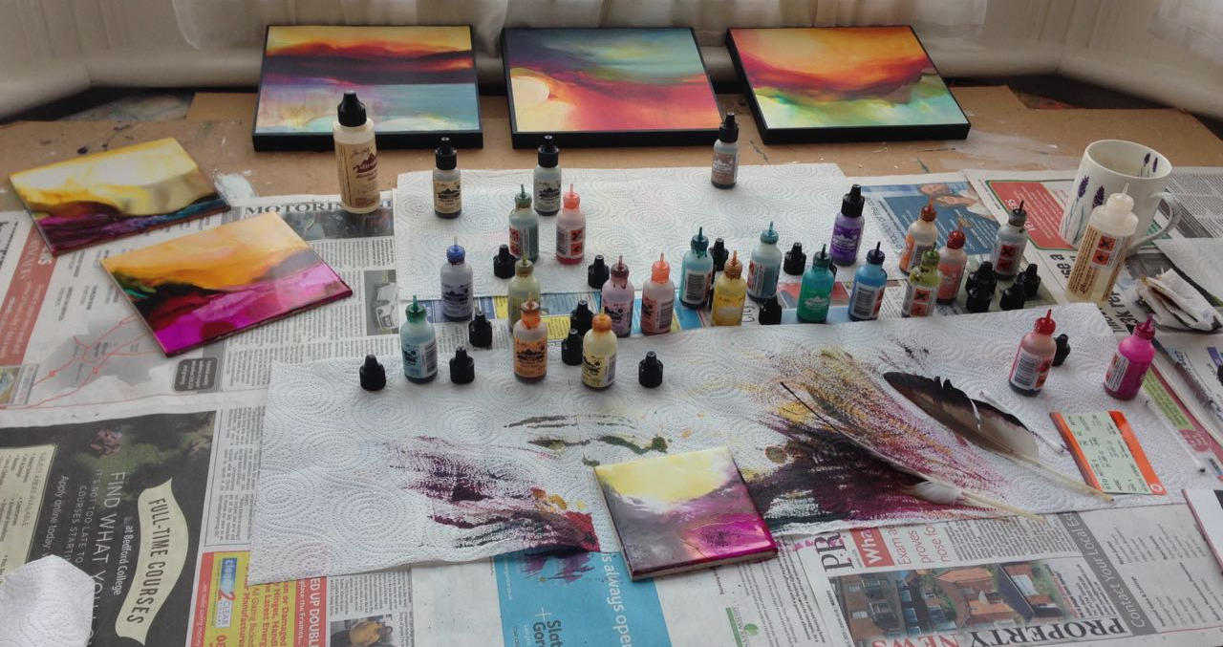
Painting items [title]

Note. Three types of notes (general, specific, and probability) can appear below the figure to describe contents of the figure that cannot be understood from the figure title, image, and/or legend alone (e.g., definitions of abbreviations, copyright attribution, explanations of asterisks use to indicate p values). Include figure notes only as needed.
Citations
The whole citation should follow the APA style, enclosed within parentheses (author surname, year) if not a natural part of the surrounding sentence; the year should be enclosed within parentheses if the names do form a natural part of the surrounding sentence. Citations of works by two authors should have ‘and’ (not an ampersand) between the names. Citations of works by more than five authors should have the first author followed by et al. in italics with no trailing stop.
In-text citations should be listed in chronological order (e.g. author1, 2002, author2, 2004, author3, 2008). Publications by the same author(s) in the same year should be identified with a, b, c (e.g. 2008a, 2008b) closed up to the year.
In parenthetical citations, use an ampersand (&) between names for a work with two authors or before the last author when all names must be included to avoid ambiguity.
e.g. (Rabbitt, Alex & Lyon, 1982)
In narrative citations, always spell out the word “and.”
e.g. Rabbitt, Alex and Lyon (1982)
When a cited work has more than five authors in the text, the form (main author et al. year) is used (Don’t forget to italicize et al.).
In scholarly work, a primary source reports original content; a secondary source refers to content first reported in another source.
e.g. (Rabbitt, 1982, as cited in Lyon et al., 2014)
Short quotations within the text should be marked with double quotation marks: Lawson also has a broad understanding of design when he mentions: “Professional designers such as architects, fashion designers and engineers” (Lawson, 2004, p.5). Longer quotations of more than one line should be formatted as below, again within double quotation marks:

“More of the goods and services produced for consumer across a range of sectors can be conceived of as ‘cultural’ goods, in that way they are deliberately inscribed with to generate desire for then amongst the end uses sold to consumers in terms of particular clusters of meaning indicates the increased importance of ‘culture’ to production circulation of a multitude of goods and services.” (du Gay, et al, 1997, p.24) [Long quotation]

A reference list should appear at the end of the paper under the heading "References". All the references should be arranged in alphabetical order. Please follow the examples below (cf. References).

Acknowledgements
Any acknowledgements authors wish to make should be included in a separate headed section at the end of the manuscript but before the list of references.

References [Start from a new page]
All references must meet APA style.
Book – Author(s) of book – family name and initials. (Year). Title of book – in italics, Edition, Publisher, Location of publication.
Jackson, L. M. (2019). The psychology of prejudice: From attitudes to social action (2nd ed.). American Psychological Association.

Journal Paper – Author(s) of journal article – family name and initials, use & for multiple authors. (Year). “Title of the journal article”, Journal name – in italics, Volume, Issue or number, Page number(s), DOI or Web address - if available.
Grady, J. S., Her, M., Moreno, G., Perez, C., & Yelinek, J. (2019). Emotions in storybooks: A comparison of storybooks that represent ethnic and racial groups in the United States. Psychology of Popular Media Culture, 8(3), 207–217. https://doi.org/10.1037/ppm0000185

Online Sources - Author(s) of page – person or organization, use & for multiple authors. (Year, Month Day - if available). “Title of page”, Website name. Web address.
Ouellette, J. (2019, November 15). Physicists capture first footage of quantum knots unraveling in superfluid. Ars Technica. https://arstechnica.com/science/2019/11/study-you-can-tie-a-quantum-knot-in-a-superfluid-but-it-will-soon-untie-itself/

Conference Paper – Author(s) of paper – last name and initials, use & for multiple authors. (Year). “Title of paper”, Conference Name. Location and Date, Place of publication: Publisher.
Evans, A. C., Jr., Garbarino, J., Bocanegra, E., Kinscherff, R. T., & Márquez-Greene, N. (2019, August 8–11). Gun violence: An event on the power of community [Conference presentation]. APA 2019 Convention, Chicago, IL, United States. https://convention.apa.org/2019-video

Thesis - Author(s) of thesis – family name and initials. (Year). “Title”, level of theses, University, city.

Kabir, J. M. (2016). Factors influencing customer satisfaction at a fast food hamburger chain: The relationship between customer satisfaction and customer loyalty (Publication No. 10169573) [Doctoral dissertation, Wilmington University]. ProQuest Dissertations & Theses Global.

Appendix [Start from a new page]
Add your tables and figures or captions separately as formatted in earlier instructions
Name them accordingly to the table or figure number and description

